# Week 1 Responsive Web Apps

Task 1

<https://github.com/Davym8/Webappstask1.git>

code and images of website.

Create a html page by scratch with having a little bit of knowledge in high school was hard and I needed to brush up and learn through YouTube videos and read the guides on websites detailing how to create a website. For starters I knew that I needed to get a layout going with the website such as a header, footer, columns, rows link fields, body and various other templates. Next is to get the titles set, links and text were set in as well as an image.

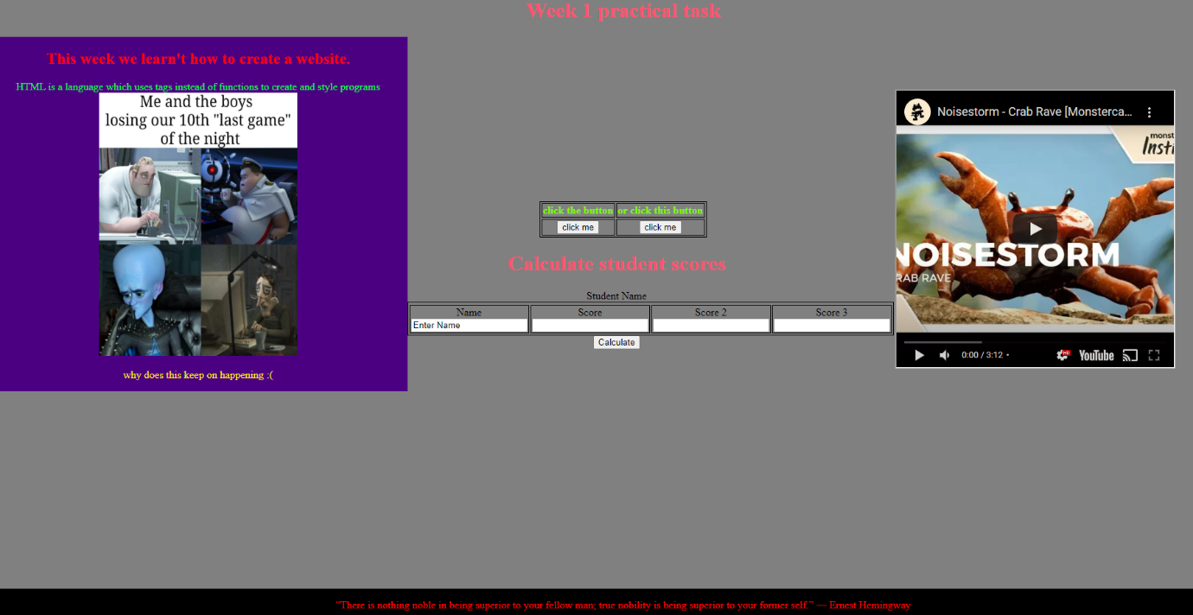

**Task 2:** Adding internal and external styling rules to the html page was simple and easy to make but realizing the layout of the columns as well as the wrapping covering the layout was helping me learn how to design the website.

**External stylesheet**

**OUTPUT**

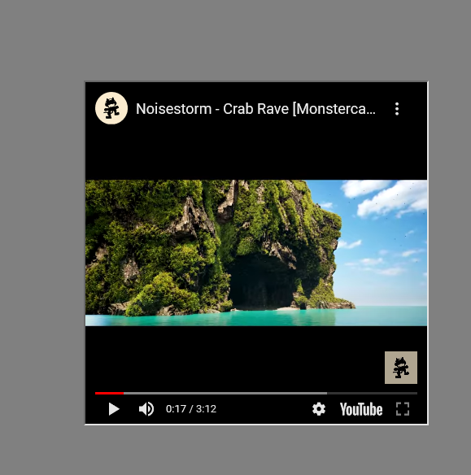

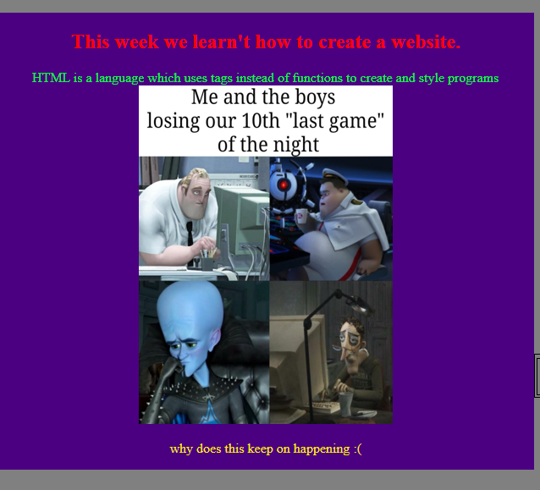

**CODE:**

.footers {

    background-color: black;

    position: fixed;

    left: 0;

    bottom: 0;

    width: 100%;

    color: red;

    text-align: center;

}

.vidoeframes {

    position: relative;

    top: 80px;

}

<style>

body { margin: 0;}

.headers {

  text-align: center;

}

    h1 {color: rgb(255, 83, 112);}

    h2 {color: red;}

    p1 {color: rgb(2, 255, 57);}

    .column {

            float: left;

            width: 33%;

            height: 100%;

        }

    .columnafters {

        float: left;

        width: 33%;

        height: 100%;

    }

</style>

<div class="header">

    <h1>Week 1 practical task</h1>

    <div class="column" style="background-color: indigo;">

    <h2> This week we learn't how to create a website.</h2>

    <p1> HTML is a language which uses tags instead of functions to create and style programs</p1>

    <img src="memes.png" width="300" height="400">

    <p style="color: rgb(255, 238, 0);"> why does this keep on happening :( </p>

    </div>

Task 3

I added some JavaScript functions for the buttons which link to websites, furthermore I also implemented a function which takes user input for a person to enter scores which is then calculated to get the average.

**OUTPUT**

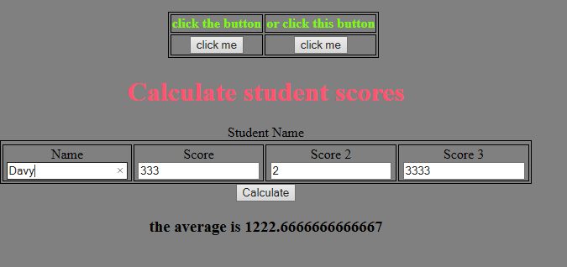

**CODE:**

<h1>Calculate student scores</h1>

        <style>

            table, row, column {

                border: 1px solid black;

            }

        </style>

        <table style="margin: auto;">

        <tr>Student Name</tr>

        <td>Name

<div class="columnafters">

        <style>

            table, th, td {

              border: 1px solid black;

            }

            </style>

        <table style="margin-top: 250px; margin-left: 200px;">

            <tr>

                <th style="color: lawngreen;">click the button</th>

                <th style="color: lawngreen;">or click this button</th>

            </tr>

            <tr>

                <td>

                    <button onclick="location.href='https://chrismckenzie.com/'" type="button"> click me

                    </button>

                </td>

                <td>

                    <button onclick="location.href='https://www.youtube.com/watch?v=ZZ5LpwO-An4'" type="button"> click me

                    </button>

                </td>

            </tr>

        </table>

        <h1>Calculate student scores</h1>

        <style>

            table, th, td {

                border: 1px solid black;

            }

        </style>

        <table style="margin: auto;">

        <tr>Student Name</tr>

        <td>Name

            <label>

                <input type="text" id="name" name="name" value="Enter Name">

            </label>

        </td>

        <td>Score

            <label>

                <input type="int" id="scoreval" name="score" value="">

            </label>

        </td>

        <td>Score 2

            <label>

                <input type="int" id="scoreval2" name="score" value="">

            </label>

        </td>

        <td>Score 3

            <label>

                <input type="int" id="scoreval3" name="score" value="">

            </label>

        </td>

        </table>

        <button onclick="calculaters()">Calculaters</button>

        <h3 id="answers"></h3>

        <script>

            function calculaters()

            {

                var value1=document.getElementById("scoreval").value;

                var value2=document.getElementById("scoreval2").value;

                var value3=document.getElementById("scoreval3").value;

                var input=parseFloat(value1)+parseFloat(value2)+parseFloat(value3);

                var result = input / 3;

                if(!isNaN(result))

                {

                    document.getElementById("answers").innerHTML="the average is " + result;

                }

            }

        </script>

    </div>

Task 4

I used Vue to modify and change the to do list and see what I could do with it however ultimately, I need to learn JavaScript and Vue as well to see what I can do.

CSS CODE

body {

    background: #20262E;

    padding: 20px;

    font-family: fantasy;

  }

  #app {

    background: #cf178e;

    border-radius: 6px;

    padding: 25px;

    transition: all 0.5s;

  }

  li {

    margin: 10px 0;

    cursor: pointer;

    position: relative;

    padding: 16px 12px 8px 50px;

    list-style-type: none;

    background: #e3df0e;

    font-size: 20px;

    transition: 0.5s;

  }

  h2 {

    font-weight: italic;

    margin-bottom: 20px;

  }

  del {

    color: rgba(0, 0, 0, 0.3);

  }

**HTML:**

<div id="app">

<h2>Todo list:</h2>

<ol>

<li v-for="todo in todos">

<label>

<input type="checkbox" v-on:change="toggle(todo)" v-bind:checked="todo.done">

<del v-if="todo.done">

{{ todo.text }}

</del>

<span v-else>

{{ todo.text }}

</span>

</label>

</li>

</ol>

</div>

**VUE.JAVASCRIPT**

new Vue({

el: "#app",

data: {

todos:

[

{ text: "Learn JavaScript", done: false },

{ text: "Learn Vue", done: false },

{ text: "Learn HTML", done: true },

{ text: "Pass the unit", done: true },

{ text: "cry alot", done: true }

]

},

methods: {

toggle: function(todo){

todo.done = !todo.done

}

}

})

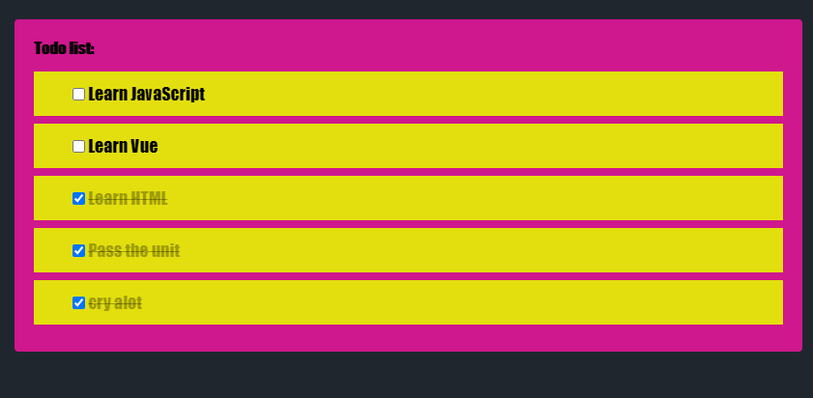

**Reflection Conclusion**

So, in retrospect doing this task with no clue on website creation I’m pretty satisfied with what I’ve done so far however I do need to watch more tutorials and research design and coding syntax. The code so far is similar to other languages I’ve studied however I’ve found that the Vue, html and CSS are somewhat messy in encapsulating all the required designs. Which I’m still getting used to wrapping my head around. All in all, the website uses the CSS file and a file for images and within the file I’ve managed to create a simple website detailing stuff. I Believe this task was good in how it introduced basic website coding techniques however I do suggest that we cover vue js in practicals and learn coding concepts together as a cohort to make this unit better for everyone.